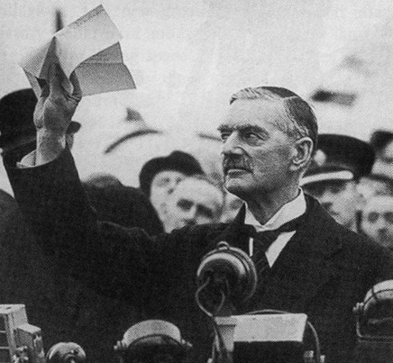
Chamberlain holds up the treaty with Hitler, which he claimed would ensure
“peace for our time.”

